Special Events Agenda
October 9, 2019

Present: Brenda Jorett, Maria Found, Linda Murray, Christine Collins, Maryann Murray

- Fundraising and sponsors. $2255.00 update today
  - Accounting: sent with agenda
    - Brewster (Maria) $100
    - Harvest (Maria) $100
    - Meredith Village (Christine) $300
    - Please add your $$ to the master list! The link is HERE.
  - Update on sponsors: Maria master list send with agenda
  - Other
- Entertainment
  - Scavenger Hunt-
    - Prizes – MaryAnn has quite a few prizes from the church and has not yet done any of the town. Will be fine going to Harvest to ask for $10 gift card. Brenda hopes to do a man/woman/child basket. Has tennis racquets from hole in the wall. Maria will send chocolate basket lady contact info to MaryAnn to solicit.
      - After we have all the prizes, let’s organize them and decide where they go.
      - Get together the week before and line up the prizes.
    - Time? 10:00 to 12:30pm
    - Place: start and end at Great Hall
    - Help with the development of items to find? Patti Cain will help Mary put this together.
  - Activities and Games
    - Time: 10:00-2:00pm
    - Place : Great Hall
    - Face Painting-be separate from Princess who might do this.
    - Princesses-yes
    - Smoothie Bicycle - Josh
    - Mo the Balloon Man- $500.00
    - Games-Parks Rec
    - NH Farm Museum will have a table
    - Food Kingswood Youth Center
    - Yum Yum Shop
    - Police and Fire Fighters (Christine to get confirmation)
    - Other vendors
    - Set up of space (Christine to submit to Linda so she can do the application)
  - Magican
    - Who? Maria to solicit the magicians and finalize
    - What time?
    - Where
    - Cost $400-450
  - Family Game Show
    - Who: Brewster
    - Where: Brewster Estabrook
    - What time: 1–2:30pm
    - Cost. $200 for prizes
  - Bingo
    - Christian will organize
    - Rules: new entry only during a new game, limited to the number of tables
    - Where: Brewster Estabrook
    - Time: 3–4:30pm
    - Cost
  - Animal Show
    - Who? Squam Lake Science Center /Wildlife encounters/other?
    - Where: Great Hall
    - Time: 5-6pm
    - Cost: Donated by Children’s Center
  - Expression Dance Academy
    - Time if they would like to perform (Christine)
    - Cost if any: N/A
    - Place: Great Hall 12-12:30pm time slot
  - Story Teller
    - Who
    - Where
    - Cost
  - Contra dancing
    - 7:00-9:00 Great Hall
    - Cost- $300.00
  - Bands
    - Who: Freese Band / others (Peter Imsey spelling?)
    - Cost: $600.00 (if 5 people $500)
    - Where: Anderson Hall
    - When (earlier the better) 60-90min (set up time 45 min)
    - OTHER IDEA if we wanted to add but keep in mind for next year: String Equinox Shanna Aisenberg (acoustic/string) and ___. $200 backgroup; $250 1 hour concert program.
  - All Saints Church dinner
    - Lasagna Dinner take care of by All Saints
    - Accordion Player- Gary Sredzienski schedule and paid for
  - Senior Center – will be part of the event
    - Band: if they like this band on Oct 30th they will pay and book it for Last Night
    - Time:
    - Place: Community Center
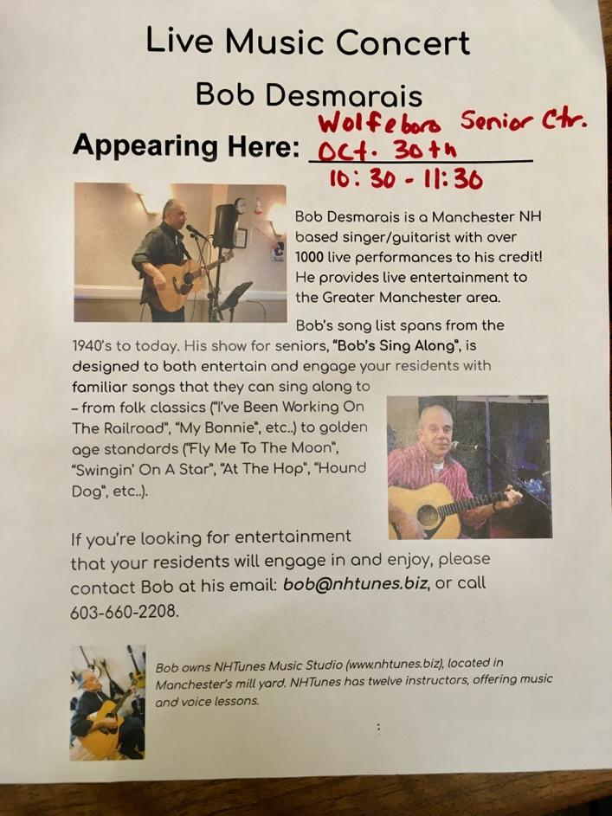
  - GAME SHOW
    - Brewster
    - Brewster Estabrook
    - $150
- Schedule and venues-schedule attached
  - Assign times
  - Assign venue
Schedule 2019
Time Event Place Volunteer
10:00 -12:30 Scavenger Hunt Great Hall MaryAnn
10:00–2:00 Games & Activities Great Hall Christine
Food Booth Maria/KYC
Balloon man Allan
12:00–12:30 Expressions Dance? Great Hall Christine
1:00–2:30 Family Game Show Estabrook Maria
2:00–3:00 Sr Center Sing-Along FCCW Linda
2:30–3:30 Mad Science Great Hall Maria
3:00–4:30 Bingo Estabrook Christine
4:00-5:00 Freese Band? Anderson Brenda
5:00-6:00 Wildlife Encounters Great Hall Linda
5:00-7:00 Dinner All Saints Alan
6:30 Fireworks Downtown Chamber
7:00-9:00 Contra Dance Great Hall Linda
STILL TO DO BELOW!!!!
- PR
  - Where: Many online and social media venues plug in town signage, plug GSN, Alton news, etc
  - Who: Brenda, Maria… all??
  - Flyer design: Brenda with posters/big flyers and Maria does mini flyers for parades and grocery stores
  - Black Smith Printing: Doing Banners
- Donation Jar
  - Where
  - How many
- Questionnaire
  - Paper/Electronic
  - Design

NEXT MEETING Oct 22nd 6:30pm LOOKING TO BE AT TOWN HALL
NOTE: Maria looking to secure all EVENT contact names and info for LNW for us to have on file for future years!! Maria started putting the info (Mad Science, Animal Encounters, Freese band, etc!) into a shared google doc HERE. We should keep all information in one area for future years (One spreadsheet for sponsor donors and one for performers/events/activity contact info and costs)

Respectfully submitted,

Maria Found

