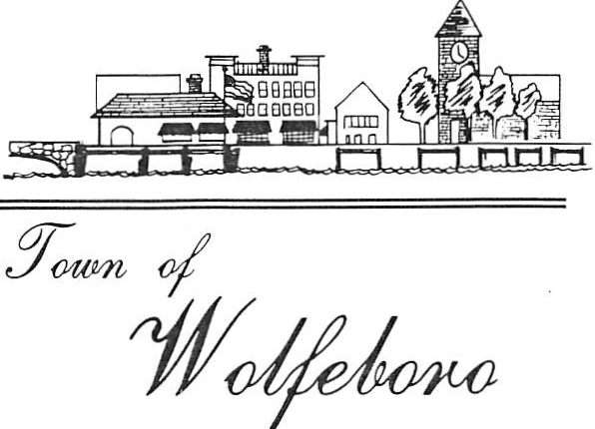
ZONING BOARD OF ADJUSTMENT

PUBLIC NOTICE
ZONING BOARD OF ADJUSTMENT
WOLFEBORO, NEW HAMPSHIRE

Notice is hereby given that the Zoning Board of Adjustment will meet on Monday, 3 June 2019 at 7:00 PM in The Great Hall at the Wolfeboro Town Hall to conduct the following business:

TM# 201-9 Case # 07-V-19
Applicant: Albert & Sandra Minotti

Public Hearing for a Variance under Article 175, Section 80 of the Wolfeboro Planning & Zoning Ordinance to permit the construction of a garage within the side setbacks. This property is located at 63 Port Wedeln Road. A site visit will be held at approximately 6:35 pm prior to the public hearing.

Plans and materials related to these applications can be viewed at the Planning and Development Office.
If there is anyone needing modifications and / or auxiliary aid to access this meeting, please notify the Planning Department at least 72 hours prior to this meeting.

Posted: 23 May 2019 - Wolfeboro Town Hall & Public Library
Published in the 23 May 2019 Edition of the Granite State News

